**Trading In Consolidations**

The longer the consolidation the more orders they are able to stack

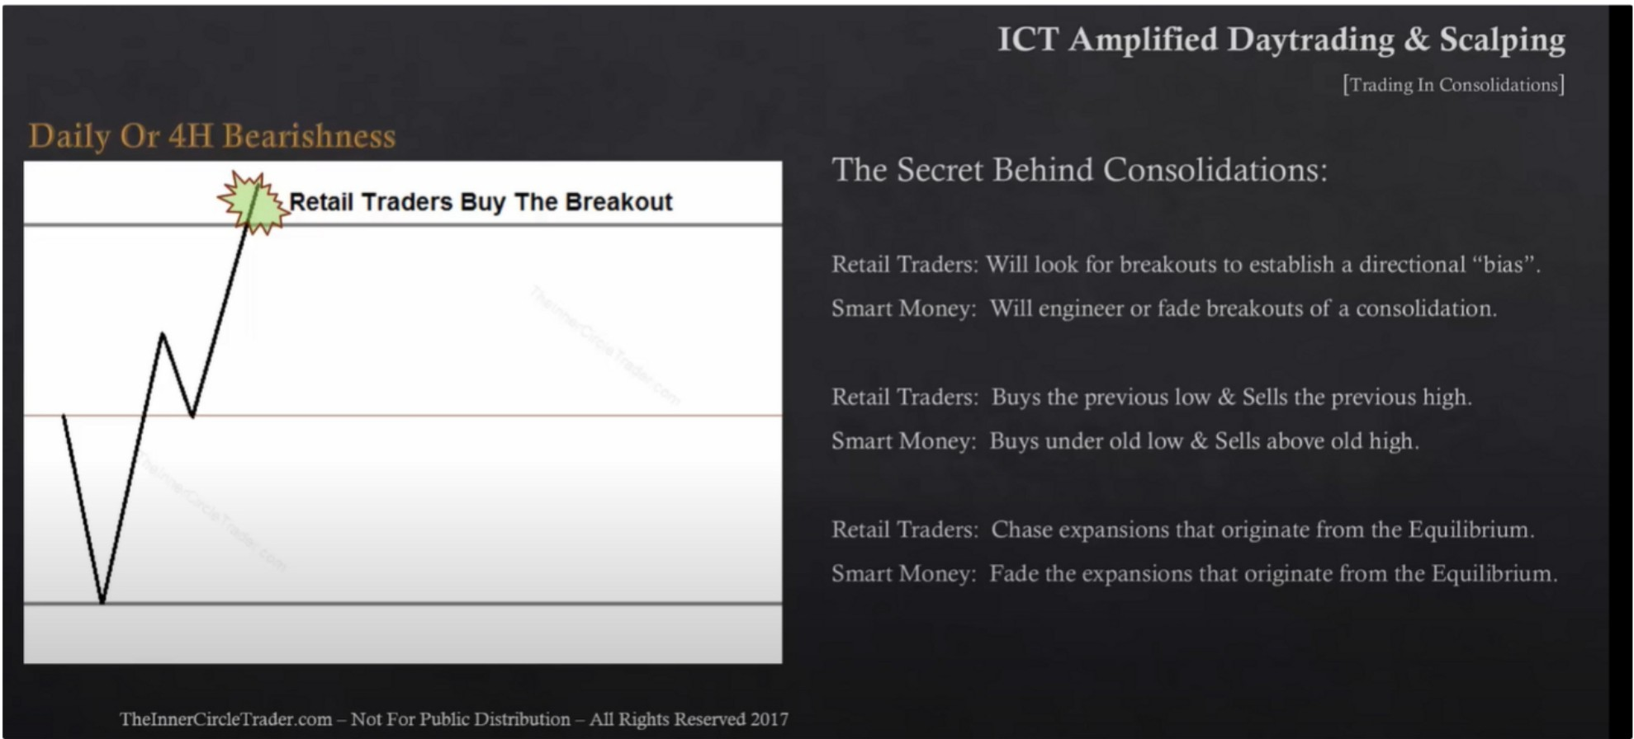What the direction of the daily or 4h is, thats going to be the direction of the move outside the consolidation most often. So if price moves above the consolidation and price bearish thats usually going to be the best scenario for trading outside the consolidation

Expect price to reprice to the EQ of the consolidation once we snap out of it

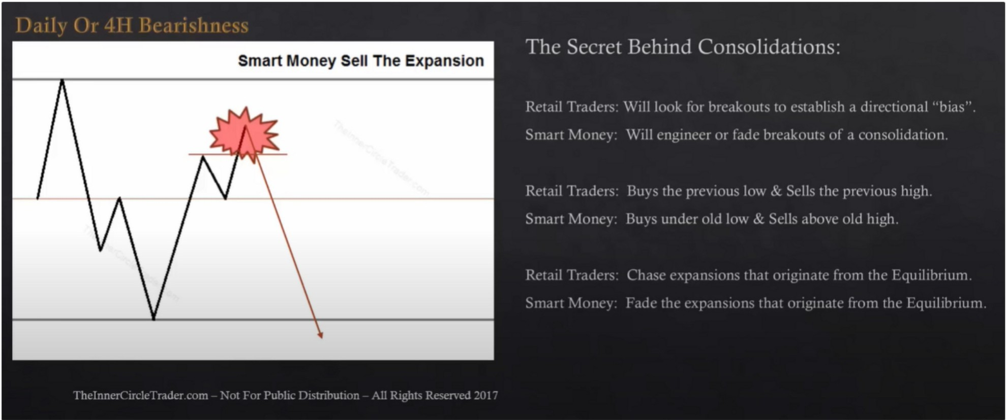

Short term high above EQ Watching for the 2nd time:

Focus on the daily and or 4h orderflow, is it likely to go higher or lower on the daily.

The 4h chart is your last line of defense in terms of determining directional bias, preferably you want to trade with 4h and daily aligned

The consolidation we look for will be on 1h timeframe or 15m

I) 1 I t li 11l t l 1! I I i11\\ '--,11:1111 (illl I 11111

The Secret Behind Consolidations:

**Old High** - **Retail Resistance**

Equilibrium

**Old Low** - **Retail Support**

RL'l,lil Tr,1dns \Viii luuk tur brL'.lkuuts tu L'St.iblish .i dnectiun.il "bi.is'

Sm,nt i\1onn \\'ill enginen nr f,1de hre,1kuub of ,1 l·nnsoltd,11illll

RL·t.iil Tr.idns lh1ys the prl'\ 1ou low...\:. SL·lls the prl'\ iou:-, high. Sm,111 J\111t1L'\ Hu\·s undn nld lnw & SL'lls ,1bnn· nld high

Rl·L1il Tr.1dn, Ch,hl' ('\p,111,;i1111, 1h,11 \ll"l. '.il1,ltl' frnm tht· rquilibr:11111

1:1.111 \1Plll"\ J.1 1l' till' l"\[,,l!l'-.](111:-- !ll,ll 1i:u..:1:L!ll' l:11:11 llll' I.L]ll:'.1br: 1:11

Open float is the building up of ordeers above and below the current market price The longer the consolidation the more orders theyre building up

Whatever the direction of the daily and or 4h is thats going to be the move outside of the consolidation most often. So if price moves above the consolidation and price bearish thats usually going to be the best scenario for trading in the consolidation

When we move away from EQ and break a short term high then thats our sell scenario

We do not always hold to the opposite end of the consolidation, we aim for the EQ of the consolidation unless we buy/sell the expansion then we do aim for the opposite end of the consolidation because we buy/sell inside the consolidation

We wait for price to take out the high/low before we sell/buy, retail will expect it to hold, we dont

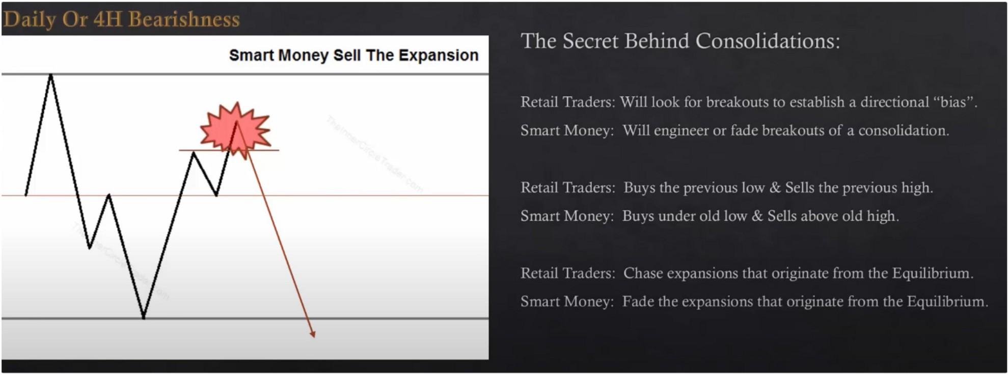

For directional bias: Are we respecting a daily PD array and are we reaching for an opposite PD array

That short term low could be in many cases the asian low, or the previous days low Focus primarily on the 4h and daily for daytrades

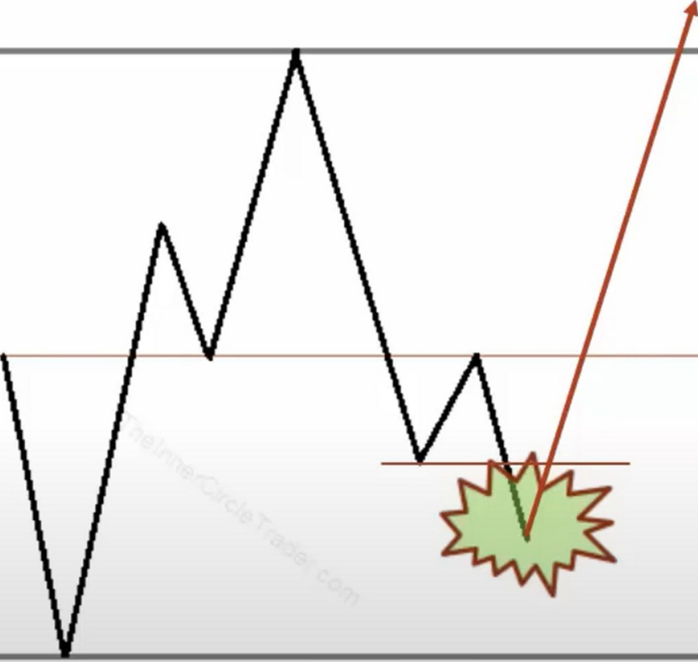

**Smart Money Buy The Expansion**

Arjo I Twitter, lnstagram I Linktree

Linktree. Make your link do more.

I https://t.co/HhmmTN1fUI

JavaScript is not available.

***"'!JI*** https://twitter.com/arjoio